National Real-Time Payments System
Prepared for: Emily Watson (IT Technical Lead, UK)

Table of Contents
1. Introduction 3
2. System Architecture Overview 3
3. Platform Vision and Objectives 4
4. Key Stakeholders 4
5. Core Functional Capabilities 5
6. Security and Compliance 5
7. Scalability and Performance 6
8. Reliability and High Availability 6
9. Fraud Detection and Risk Management 7
10. Future International Expansion 7
11. Transaction Processing Flow 7
12. Microservices Architecture 8
13. Global Benchmark Comparison 9
14. Business Impact and ROI 9
15. Conclusion 10

1. Introduction
The National Real-Time Payments System is envisioned as a large-scale digital financial
infrastructure that enables citizens, merchants, and financial institutions to perform
instant transactions. The goal of the platform is to replace traditional delayed banking
transfers and reduce reliance on physical cash. By creating a reliable national payment
backbone, the system will improve financial inclusion, speed of commerce, and transparency
in the economy.
Real-time payment systems have become a critical component of modern digital economies.
Countries across the world have adopted similar systems to accelerate financial
transactions and improve accessibility for both consumers and businesses. The proposed
platform will support millions of users while maintaining extremely high reliability,
security, and scalability.

2. System Architecture Overview
The architecture follows a distributed platform model designed to handle large
transaction volumes and ensure high availability. Incoming traffic is handled by
an API gateway which routes requests to specialized microservices responsible
for authentication, payment processing, fraud detection, and settlement.
This layered architecture ensures that different components can scale independently
while maintaining reliability and performance under heavy load conditions.

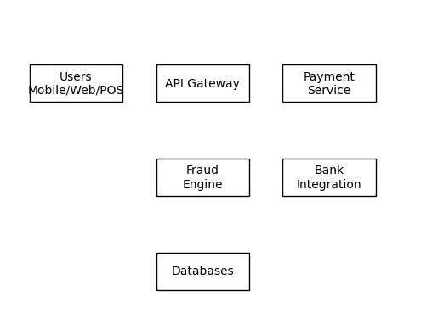
Fig: High-Level System Architecture

3. Platform Vision and Objectives
The platform aims to provide a seamless digital payment experience where transactions
can be completed in seconds. The system will support peer-to-peer (P2P) transfers between
individual users and peer-to-merchant (P2M) payments for businesses.
Key objectives include:
• Providing instant payment capabilities nationwide.
• Supporting integration with all major banking institutions.
• Enabling secure mobile and web-based payment services.
• Offering merchants an easy-to-use digital payment acceptance solution.
• Ensuring the platform can scale to support millions of concurrent users.
The long-term vision also includes enabling cross-border payment functionality that
connects the national system with international banking networks.

4. Key Stakeholders
Several stakeholders interact with the platform.
Citizens represent the primary user group and use the platform for everyday financial
transactions such as sending money to family members or paying for goods and services.
Merchants use the system to accept digital payments through QR codes or POS integrations.
Banks and financial institutions are responsible for maintaining user accounts and
facilitating settlement processes. Regulators and auditors oversee the system to ensure
compliance with national financial regulations and data governance requirements.

5. Core Functional Capabilities
The payment platform must support a wide range of core capabilities to ensure a smooth
user experience.
User onboarding processes must include identity verification and Know Your Customer (KYC)
procedures to comply with regulatory requirements. Users must be able to link multiple
bank accounts to their profiles.
The system will allow real-time payments between users and merchants. When a payment
is initiated, the platform processes the request instantly, verifies the availability
of funds, performs security checks, and updates both sender and receiver accounts.
Users should also have access to transaction history, receipts, and status notifications.
Merchants require dashboards that provide insights into daily revenue, transaction
volumes, and settlement summaries.

6. Security and Compliance
Security is a critical requirement for any financial payment system. The platform must
protect sensitive financial data and prevent unauthorized access.
Encryption must be implemented for all data transmitted between clients and servers.
Additionally, sensitive data stored within databases must also be encrypted to protect
against data breaches.
The system should comply with globally recognized security standards such as PCI DSS
and ISO 27001. Strong authentication mechanisms including multi-factor authentication
should be used to verify user identities.
Regulatory compliance is equally important. The platform must adhere to national
financial regulations as well as data residency and privacy laws.

7. Scalability and Performance
The system must support extremely high transaction volumes. With over 150 million
registered users and tens of millions of daily active users, the infrastructure must
be capable of processing thousands of transactions per second.
To achieve this, the architecture should adopt distributed microservices that allow
different components of the platform to scale independently. Load balancers should
distribute incoming traffic across multiple service instances.
Cloud-based infrastructure can provide elastic scalability, allowing the system to
automatically allocate additional resources during peak usage periods such as
national holidays or large commercial events.

8. Reliability and High Availability
Because the system forms part of national financial infrastructure, downtime must be
minimized. The target availability is 99.999 percent.
This level of reliability requires redundancy across all system layers including
servers, databases, and network components. Automatic failover mechanisms should
ensure that if one component fails, another component immediately takes over.
Real-time monitoring and alerting systems should be implemented so that operational
teams can quickly identify and resolve potential issues.

9. Fraud Detection and Risk Management
Financial fraud represents one of the biggest risks in digital payment systems.
The platform should integrate real-time fraud detection engines capable of analyzing
transactions as they occur.
Machine learning models and rule-based detection systems can analyze user behavior,
transaction patterns, and geographic activity to identify suspicious activity.
When a potential fraud risk is detected, the system may temporarily hold the
transaction or trigger additional authentication steps. This ensures that legitimate
transactions proceed smoothly while fraudulent attempts are blocked.

10. Future International Expansion
The platform should be designed with global interoperability in mind. As digital
payments become increasingly international, the system may eventually support
cross-border transactions.
Future enhancements may include currency conversion services, international
settlement processes, and partnerships with foreign banking networks.
Such expansion would strengthen economic ties between countries and provide users
with faster and more affordable international payment options.

11. Transaction Processing Flow
When a payment is initiated by a user, the request first passes through an API
gateway. The request is authenticated and validated before being sent to the
payment processing engine. Fraud detection systems analyze the transaction in
real time to detect suspicious activity.
Once approved, the system communicates with banking networks to verify funds
and complete settlement. The receiver and sender are then notified instantly.
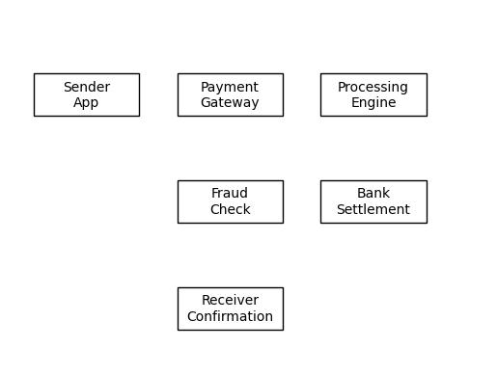

12. Microservices Architecture
To support large-scale operations, the platform is designed using microservices.
Each service is responsible for a specific function such as authentication,
user management, payment processing, fraud detection, notifications, and
settlement management.
This modular approach improves scalability, reliability, and ease of system
maintenance while allowing teams to develop and deploy services independently.
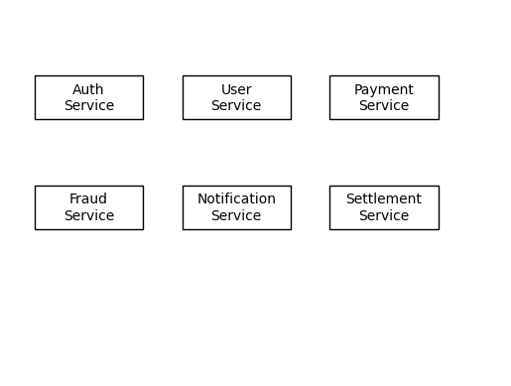

13. Global Benchmark Comparison
Several countries have implemented real-time payment platforms. Examples include
India's UPI, the United Kingdom's Faster Payments system, and the United States'
FedNow network.
These platforms demonstrate how instant payment infrastructure improves financial
accessibility, reduces transaction costs, and accelerates digital commerce.
The proposed system builds on these proven concepts while introducing additional
scalability and fraud monitoring capabilities.

14. Business Impact and ROI
The implementation of a national real-time payment system can significantly
transform the digital economy. Businesses benefit from faster cash flow and
reduced transaction costs, while consumers gain convenience and accessibility.
Increased digital payment adoption also reduces the cost of handling physical
currency and improves financial transparency. Over time, the platform can
generate economic growth by enabling innovation in fintech and digital services.

15. Conclusion
The National Real-Time Payments System represents a transformative step toward a
fully digital financial ecosystem. By combining scalable technology, strong
security frameworks, and reliable infrastructure, the platform can support
millions of users and billions of transactions.
Beyond enabling faster payments, the system promotes financial inclusion,
improves transparency in the economy, and supports innovation in digital
financial services.
With careful planning and robust architecture, the platform can evolve into
a globally connected payment network capable of supporting the future of
digital commerce.

